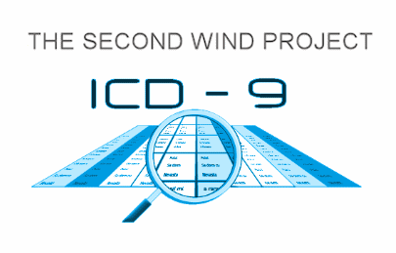

Medical Codes for Illnesses Related to BP Oil Spill
for Those Who Are Sick
ANYONE whose health has been adversely affected by the BP oil spill and the Corexit used to treat it NEEDS to know this and print and take the forms listed in the download link below to their doctor.
Quoting Trisha Springstead, RN: "If you are ill from the effects of the BP GULF OIL SPILL these codes are written and documented codes, when Medicare Creates a code this means that the illness is REAL and it is a code that can be taken to your MD and to a Hospital.”
YOU MUST PRINT ALL 6 PAGES in the link provided below, including the RED lines on the sheet and read this." FOLLOW THIS LINK - download ALL 6 pages to take with you:
http://www.cms.gov/Regulations-and-Guidance/Guidance/Transmittals/Downloads/R2999CP.pdf
What is an ICD-9 Code?
CD-9-CM (International Classification of Diseases, Clinical Modification) is a set of codes used by physicians, hospitals, and allied health workers to indicate diagnosis for all patient encounters. The ICD-9-CM is the HIPAA transaction code set for diagnosis coding.

